1. INTRODUCTION:
- Project Title:
- Team ID:
- Team Leader: M. Divya sree
- Mail id: sreed1347@gmail.com [Coder]
Team Members:
- NAME: M.Anusree
- MAILID:anusreemuruganandham2007@gmail.com[Coder]
- NAME: N.Deepika
- MAIL ID: deepikapooja2728@gmail.com [Video Editer]
- NAME: M.Dhivya sree
- MAIL ID: dhivyaleela30@gmail.com [Documenter]
- NAME: A.Ambeeleeswari
- MAIL ID: ambeeleeswari14@gmail.com [Documenter]
2. PROJECT OVERVIEW:
- Purpose :
- Platform for digitizing and managing library resources efficiently.
- Enables students and librarians to access, organize, and track books through a smart web-based system.
- Features :
- Manage book records digitally (add, edit, delete).
- Organize books by genre, author, and publication details.
- Track book issuing and returns automatically.
- View real-time availability of books.

3. ARCHITECTURE

Backend (Application Logic & Server)
• The backend is responsible for handling all business logic and processing requests from clients.
• It manages book records, user authentication, issuing/returning books, and updating availability.
• RESTful APIs are created to allow communication between the client and the database.
• Built using Node.js and Express.js for scalable and efficient server-side operations.

Database (Data Storage)
• Stores all library-related data such as books, users, issue records, and return history.
• Ensures quick retrieval and updates of information through optimized queries.
• Implemented using MongoDB, which provides flexible and scalable document-based storage.

4. SETUP INSTRUCTION

Prerequisites :
• Node.js
• MongoDB
• Git
• Express.js
• VS Code

5. INSTALLATION
▪ Clone the repository
git clone <repo-url>
▪ Navigate to the backend folder
cd server
▪ Install dependencies
npm install

6. FOLDER STRUCTURE
libspace-backend
│
├── config
│ └── db.js
│
├── controllers
│ ├── bookController.js
│ ├── userController.js
│ └── issueController.js
│
├── models
│ ├── Book.js
│ ├── User.js
│ └── Issue.js
│
├── routes
│ ├── bookRoutes.js
│ ├── userRoutes.js
│ └── issueRoutes.js
│
├── middleware
│ └── authMiddleware.js
│
├── server.js
└── package.json

7. RUNNING THE APPLICATION
▪ Start MongoDB service
▪ Run the backend server
cd server
npm start
▪ Server will run at
http://localhost:5000

8. API DOCUMENTATION

User APIs
• POST /api/users/register → Register a new user
• POST /api/users/login → Login user

Book APIs
• POST /api/books/add → Add new book
• GET /api/books → Get all books
• PUT /api/books/:id → Update book details
• DELETE /api/books/:id → Delete a book

Issue/Return APIs
• POST /api/issue → Issue a book
• PUT /api/return/:id → Return a book
• GET /api/issue/history → View issue history
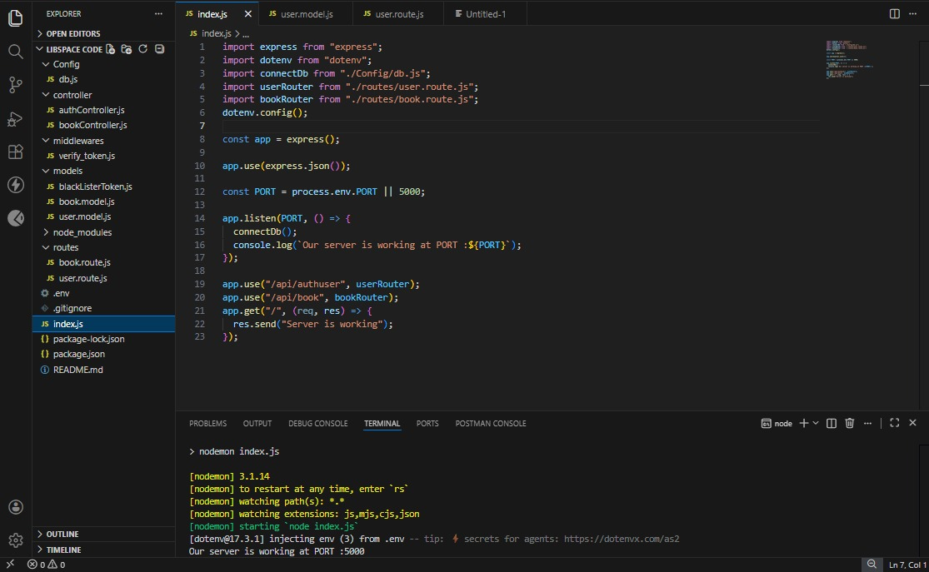
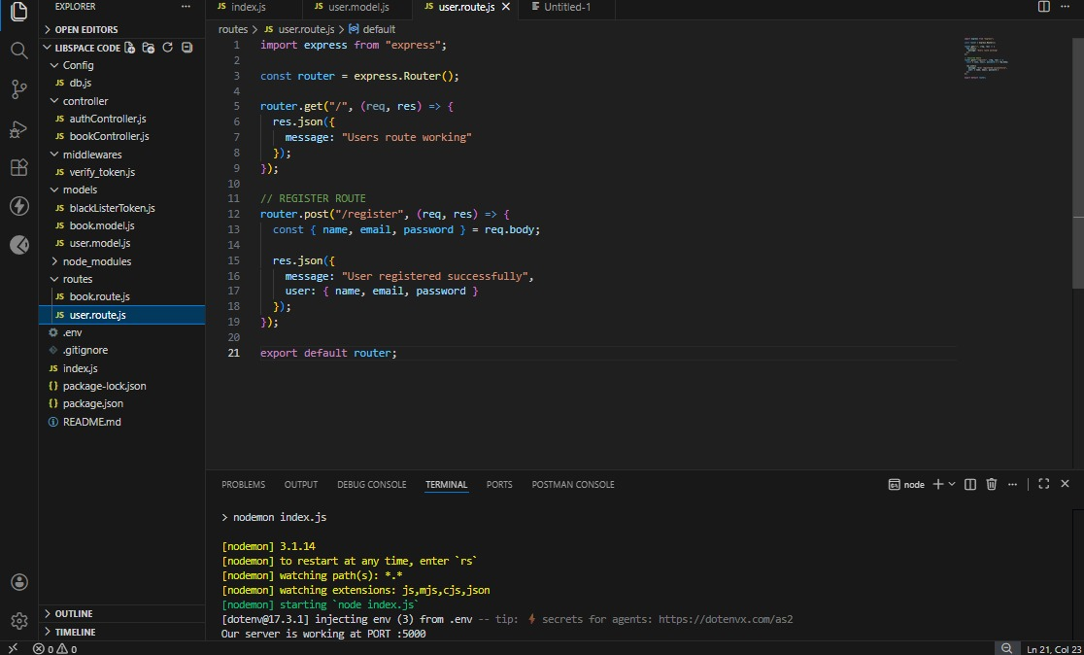

8.USER INTERFACE:

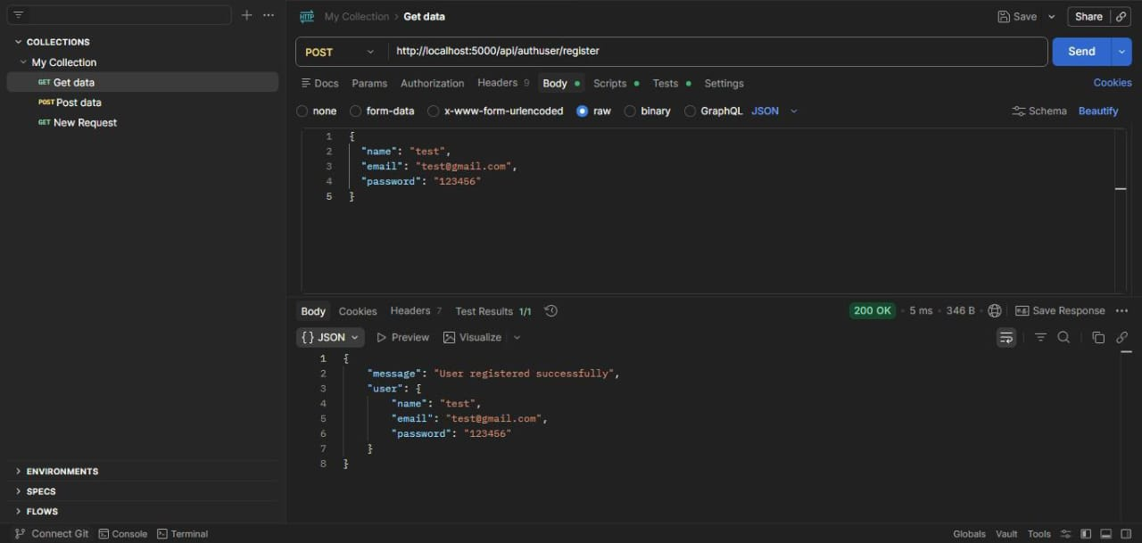
USER REGISTER

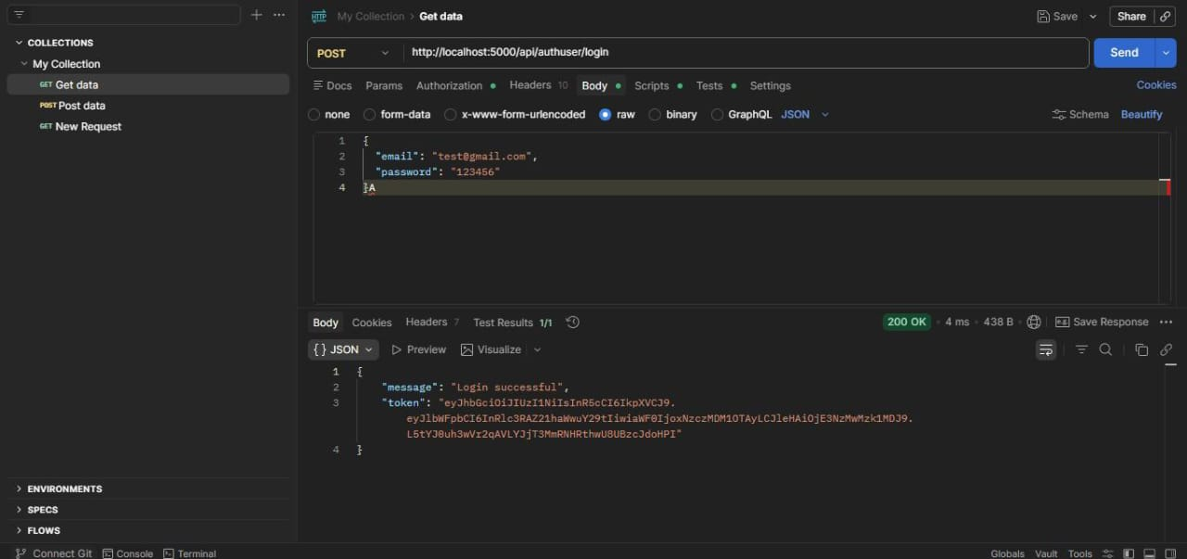
USER LOGIN

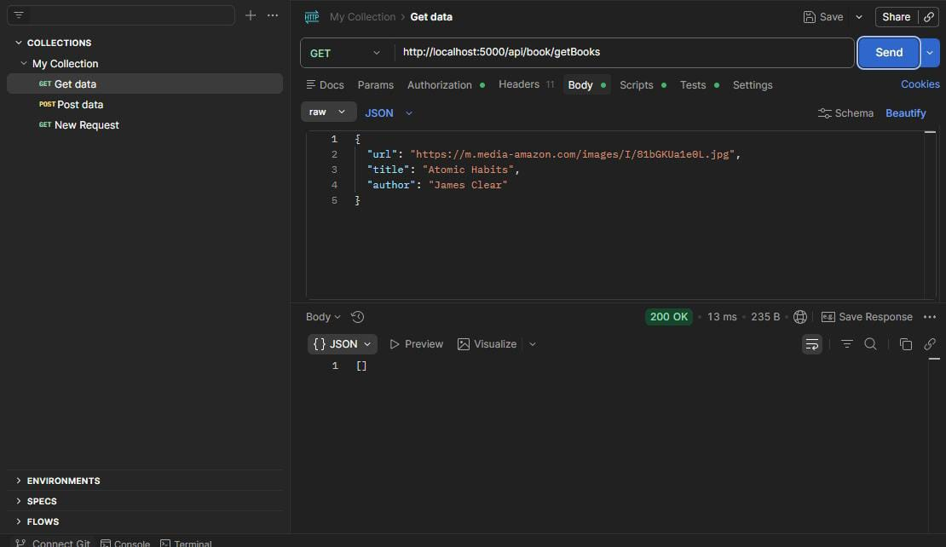
ADDING BOOKS
9. DEMO LINK
https://drive.google.com/file/d/1G3EkF9BqyStBNCZk8BNgrsMTX2s6MIEV/view?usp=drive_link

10. KNOWN ISSUES
- Limited user role management in the current system.
- Basic search functionality with limited filtering options.
- No automated notification system for due dates or overdue books.
- Manual handling of overdue fines in some cases.

11. FUTURE ENHANCEMENTS
- Implement advanced search and filtering options.
- Add automatic fine calculation for overdue books.
- Introduce email or SMS notifications for due dates and reminders.
- Integrate barcode or QR code scanning for faster book management.

